W-17
Year 10 Science
Physical Sciences
Practical Assessment - Distance and Displacement

NAME: MARK: $\frac{}{10}$

Below is a map of the school and its buildings. You need to be able to work out the distance and displacement for the following. You will need to trace onto the diagram.

Equipment: trundle wheel, 50 m tape.

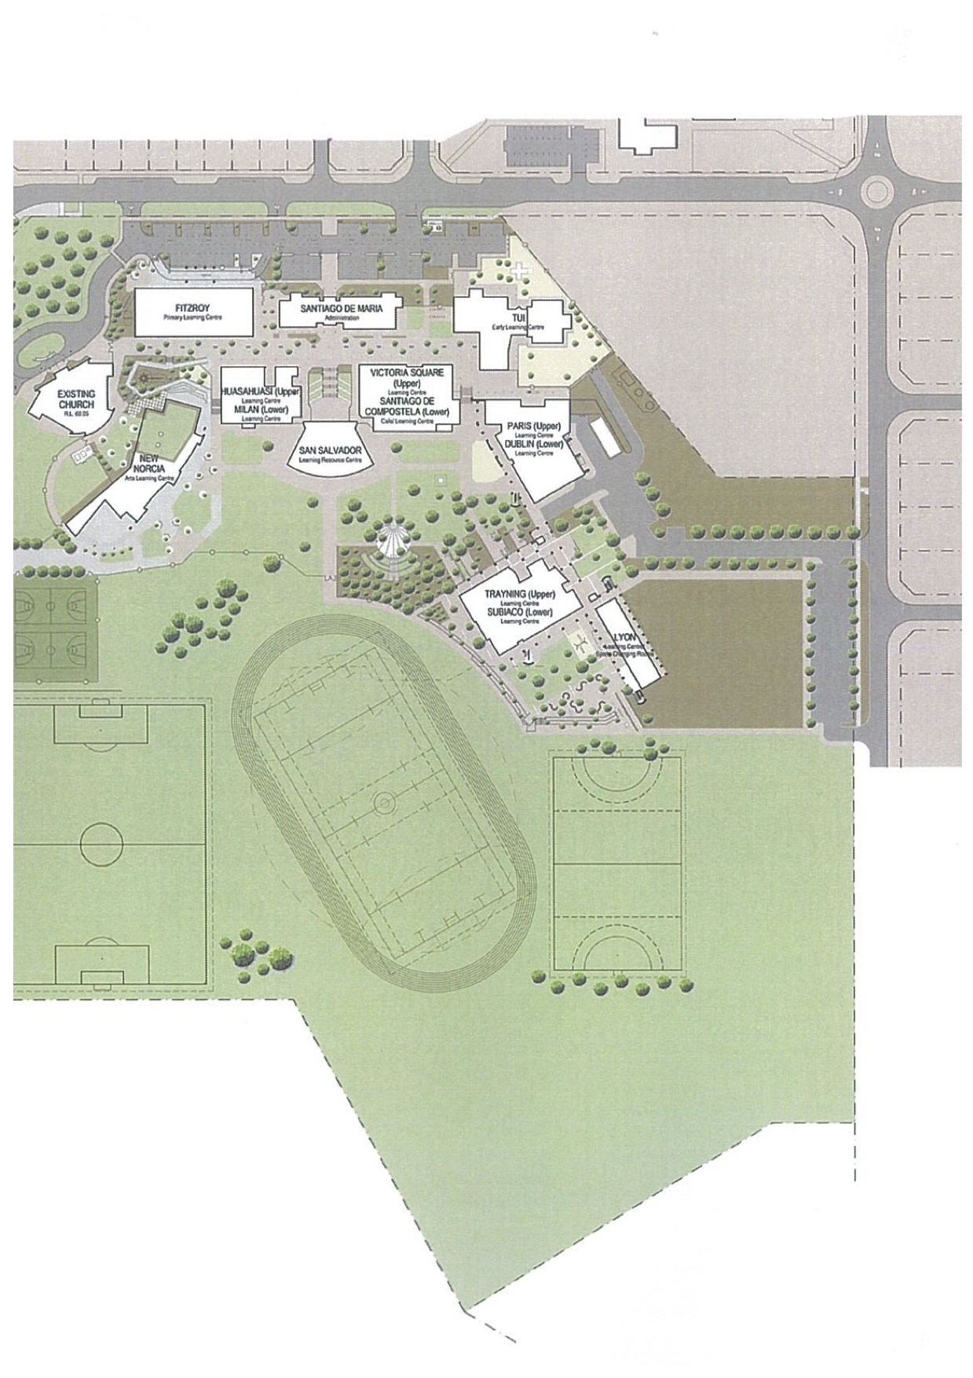

Distances

1. Doors into Victoria Square to the oval gates.

Distance =

2. Door to Huasahuasi 6 to sliding doors Lyon1.

Distance =

Scale Determination

• Use the trundle wheel or 50 m tape to measure the length of Victoria Square building along the boulevard side.

Write this onto your map.

• Measure the length of the building on the map accurately with a ruler.

Write this as a scale on the bottom of the map.

e.g. 2.5 cm = 40 m

Displacement

Now use the scale to work out the displacement for each journey.

You will need to draw cross-hairs with compass directions onto the diagram. Don't forget to put a rough direction as a bearing.

1. Doors into Victoria Square to the oval gates.

Displacement = Bearing:

2. Door to Huasahuasi 6 to sliding doors Lyon1.

Displacement = Bearing:

